*Photogrammetric Record,* xx(xxx): 000–000 (Month 20##)

Enhancing geoscience field studies with image-to-geometry registration on mobile devices

Melanie Kröhnert (melanie.kroehnert@tu-dresden.de)*

Hans-Gerd Maas (hans-gerd.maas@tu-dresden.de)

*Institute for Photogrammetry & Remote Sensing, TU Dresden, Helmholtzstr. 10, 01069 Dresden, Germany*

Christian Kehl (chke[@d](mailto:remondino@fbk.eu)tu.dk)

*Danmarks Tekniske Universitet, DTU Compute, Richard Petersens Plads, Building 324, 2800 Kongens Lyngby, Denmark*

Simon J. Buckley ([Simon.Buckley@uni.no](mailto:Simon.Buckley@uni.no))

*Uni Research AS CIPR, Nygårdsgaten 112, 5008 Bergen, Norway*

* Corresponding author

Abstract

Thanks to the rapid technological progress made to mobile devices, smartphones are increasingly valuable for performing science. They can serve as photogrammetric measurement devices due to inbuilt cameras, sensors for orientation and position assessment, as well as powerful processing units allowing field-based data acquisition and processing. This paper outlines two photogrammetric (Android) applications for annotating 3D objects via 2D image data in geology and hydrology. Relevant approaches for the field-based registration of 3D geometry and 2D smartphone images are explained, based on required information about cameras’ intrinsic and extrinsic parameters including the investigation of different sensor fusion algorithms. Considering the use of mobile devices for field-based work, the power consumption is a significant metric. Thus, we investigate field operation times for both apps with respect to 2D and 3D data interaction modes. In conclusion, we point out the usability of low-cost smartphones for applied geosciences.

Keywords: smartphone, orientation, positioning, hydrology, geology, outdoor usability

Introduction

Mobile devices are ubiquitously available in modern society. Applications for a diverse range of purposes emerged over the past decade. Such mobile devices are also increasingly applied for professional use and scientific purposes to solve computational tasks in outdoor- and field study environments. Geosciences such as hydrology, geology or glaciology rely on the documentation of field observations. In order to improve field study, these domains now attempt employing mobile devices as digital field instrument (Fig. 1).

|  |  |  |
| --- | --- | --- |
|  |  |  |

Fig. 1 Illustrative examples for geological interpretation (a) and hydrological annotation (b).

Geoscience apps for assessing two-dimensional data have been available for several years now, e.g. (Jordan, 2009). The availability of three-dimensional base data and their increasingly-easy acquisition (e.g. via Unmanned Aerial Vehicles (UAVs) applying Structure-from-Motion (SfM) (Goesele, et al., 2007; Wu, 2013) and with subsequent dense matching, enable assessing 3D data in various scenarios. The application domains benefit from the development in acquisition technology as well as fundamental 3D data processing by being able to analyse the data on small-scale devices right in the field. Furthermore, crowdsourced data and Volunteered Geographic Information (VGI) contribute to the geoscience data inventory, being acquired by citizen scientists.

Domain-specific mobile software is required to realise the various domain expert requirements on the target devices, as off-the-shelf software insufficiently addresses the envisaged usage scenario or the domain-specific data types. What makes mobile software distinct is the modality of the device. Table I sums up mobile devices characteristics in comparison to conventional working stations.

Table I Assessment of mobile devices characteristics with respect to their usability in geosciences.

|  |  |
| --- | --- |
| Advantages | Challenges |
| * mobility of smartphones/ tablets * array of sensors (position, orientation) * inbuilt camera for data acquisition * high computational qualities compared to device size * connection to largely available mobile networks for outsourcing data/ processes | * user interaction via small touch screen only * limited data memory * energy consumption * variety of the hardware and qualities, e.g. devices, sensors, etc. |

Developing geoscience, domain-specific mobile software requires to address these challenges while highlighting how the device advantages are used to support fieldwork tasks.

This article addresses the challenges of mobile sensor variability, their usage in image-to-geometry registration of point cloud base data, and the related energy consumption in comparison to a Digital Surface Model (DSM) base data mobile application. The technical research is approached via two use cases within the domains of surface hydrology and (petroleum) geology. The content covered in the article is a significant extension of earlier published research (Kröhnert, et al., 2017), focussing on extensive measurements to verify the reasoning and statements of previous studies.

The sections within this article adhere to the following structure: First, different 3D surface data representations are briefly discussed which are employed in hydrology and geology. Second, algorithmic baseline concepts that are key for 3D base data interaction on mobile devices are introduced, summarising project-internal development by the authors as well as referencing key literature on the subject. Third, the challenge of mobile sensor positioning and orientation is addressed exploring their influence when trying to register images with object data. These influences are assessed with an in-depth study measuring mobile sensors and comparing their accuracy and variability to professional Inertial Measurement Unit (IMU) reference data. Fourth, power consumption of such 3D surface data mobile applications is addressed via measurements and analysis of energy efficiency control parameters. Subsequently, a section discussed how available mobile systems are used in surface hydrology (i.e. water level gauging) and petroleum geology (i.e. field interpretation) to improve data analysis and integrate outdoor measurements in digital workflows. Then, the article is finalized with some concluding remarks and discussions for future developments in this research trajectory.

3D base data representations

Various representation forms for 3D terrain data are available. While early digital systems used gridded DEMs for their simplicity and compact storage (Trinks, et al., 2005; Leskens, et al., 2015), DSMs and Triangulated Irregular Networks (TINs) are dominating most terrain-based systems for application-specific analysis (Buckley, et al., 2008; Caumon, et al., 2013) at the moment. For triangular surfaces, it is important to distinguish geometrically valid TINs, organised as piecewise-linear complex, from polygon soup surfaces (section 1.2.2, figure 1.4 from (Kehl, 2017c)). While the latter is often employed in early stages of mesh-based software systems due to its simplicity and ease of implementation, valid TINs are employed in mature project stages as automated analysis methods (e.g. auto-interpretation, volume derivation) require clean surfaces with coherently outward-oriented surface normals.

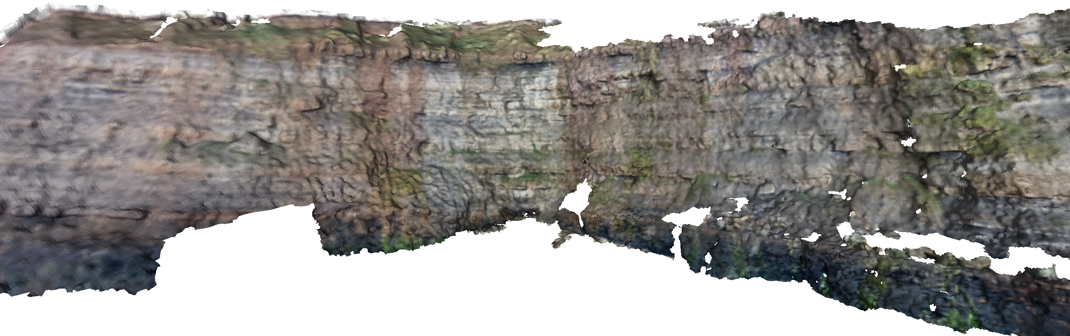

Fig. 2 Example of a Digital Outcrop Model (DOM) as textured triangular surface.

In geoscience domains such as petroleum geology, texture- and colour information are vital for interpretation- and analysis tasks. In these cases, as demonstrated by (Buckley, et al., 2008) and (Caumon, et al., 2013), the surface is supplemented with photographic information via texture projection (Fig. 2).

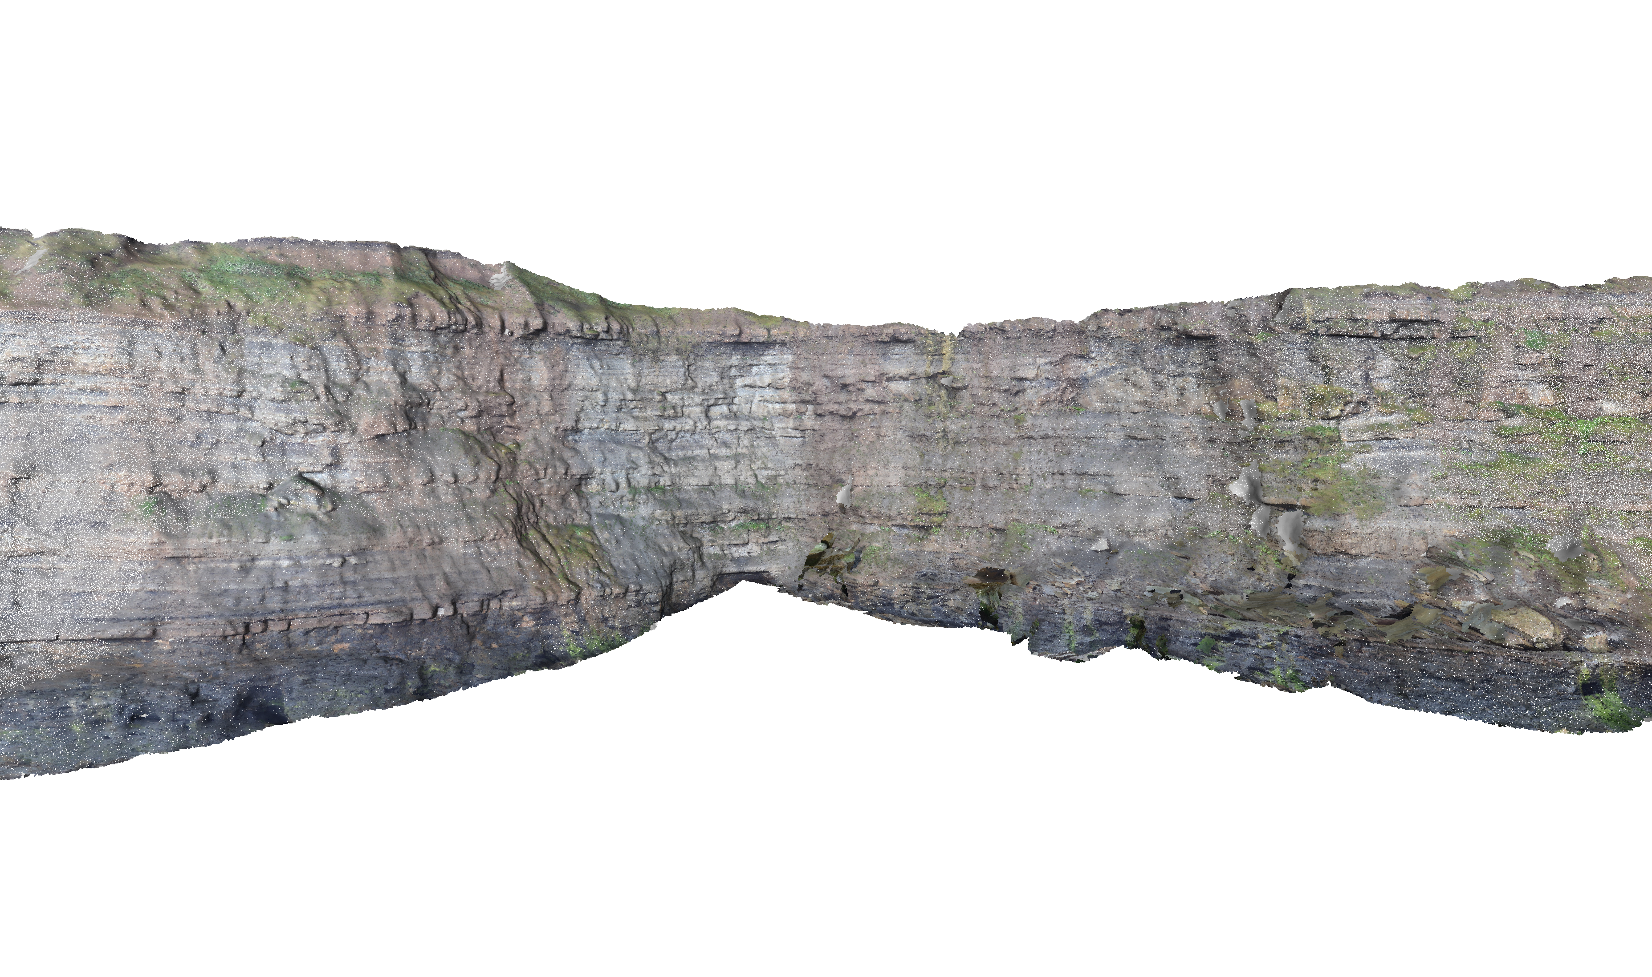

Fig. 3 Point set generated via multi-view geometry from same area as Fig. 2.

In contrast, other geoscience domains, such as hydrology and free surface flow management, used georeferenced laser scanner point clouds and coloured point data streams provided by close-range photogrammetry for small- or UAV for large-scale study cases (Fig. 3). The colour component of the base data is either provided by auxiliary photographs or embedded as part of the point cloud reconstruction (e.g. SfM). The point set surface support tasks like coastal monitoring (Letortu, et al., 2017; Medjkane, et al., 2018), monitoring river topography (Watanabe & Kawahara, 2016) and flood protection management (Leskens, et al., 2015). Nevertheless, new approaches for low-cost and on-the-fly river monitoring (Kröhnert & Meichsner, 2017) arise due to globally increasing flash flood events after heavy rainfalls (Mueller & Pfister, 2011) that are further addressed in the section *Derivation of hydrological parameters*.

Since SfM became state of the art in geosciences, the acquisition of (true-) coloured point clouds is not that difficult and commonly employed because of its rapid processing, compared to conventional approaches like Terrestrial Laser Scanning (TLS).

The above representation forms are also valid for mobile device software. Because of the limited processing speed of mobile chipsets, the usage of point clouds appears most common within the graphics literature, e.g. (García, et al., 2015). The sparse vertex distribution in point clouds can cause problems in the data analysis, which is why DEMs have seen a revival in the mobile computing domain. DEMs provide dense, closed geometric models that can be rendered and processed efficiently. Furthermore, because of the smaller device memory, the possible compression options for point clouds and DEMs are advantageous.

Algorithms

This section demonstrates novel- as well as existing algorithms and methods on mobile devices that are needed for case-specific field-based analysis within the geosciences. The effectiveness of each algorithm depends on the applied model representation and the target usage.

Mesh-based rendering

Rendering a surface model in this context refers to the image generation of the 3D base data by projective rasterization to the 2D image plane of a virtual camera. This process is performed on mobile devices for the purpose to model presentation as well as for the generation of a synthetic reference image for image-to-geometry registration. Furthermore, it can be used to synthesize an image from available 3D data for interpretation and annotation in 2D.

Algorithms for rendering textured triangulated surfaces are well-known amongst practitioners. In the common rendering pipeline, the textured mesh is transferred as a set of (attributed) vertices and primitive sets (e.g. triangles, polygons) to the Graphical Processing Unit (GPU). The virtual camera is set up using the pre-defined view projection matrix while the graphics primitives are repositioned using the model-related transformation matrix. The rasterizer projects the available 3D information into the camera plane and performs hidden-surface removal. The result is a discrete-space pixel representation. Available textures are mapped as images on the surface using the texture coordinate vertex attributes. The mesh-based rendering algorithms employed on desktop computers are analogous to mobile devices, whereas the technological details are posing the actual challenges.

A novel approach to mobile point-based rendering

In comparison to mesh-based rendering, simple point projection seems to be a nice alternative, saving computational resources and efforts for post-processing regarding outlier removal. Thus, we simply project object points onto an image plane using perspective projection, assuming a distortion-free ideal camera with centred principle point. Thus, the camera matrix $K$ equals identity matrix $\text{I}$ and can be neglected.

First, applying a six-parameter transformation transfers three-dimensional object points from world reference frame ${\vec{X}}_{W}$ into a 3D camera system ${\vec{X}}_{c}$ using equation (eq.) 1.

$${\vec{X}}_{C}=R\left({\vec{X}}_{W}-{\vec{X}}_{0}\right)$$

(1)

, where $R$ is a $3x3$ orthonormal rotation matrix and ${\vec{X}}_{0}$ the translation vector to camera's projection centre. For simplicity, the usage of the Universal Transverse Mercator (UTM) system with $x$ pointing to the east and $y$ pointing to the north with respect to the prevalent zone number. For $z$-component, the height over the Earth Gravitational Model 1996 (EGM96) is advisable to use.

Accounting for homogeneous coordinates, we can describe the relation between camera ${\vec{X}}_{c}$ and image coordinates $\tilde{x}$ involving their depth components (eq. 2).

$$\left(\begin{matrix}\tilde{u} \\ \tilde{v} \\ c_{c}\end{matrix}\right)=\left(\begin{matrix}x_{c} \\ y_{c} \\ z_{c}\end{matrix}\right)$$

(2)

For the camera's imaging plane, the constant $c_{c}$ [mm] defines the physical distance between camera sensor and its projection centre, which equals to focal length $f$ [px] in the image coordinate system. The normalization of the projected points to homogeneous coordinates is key in the further processing (eq. 3).

$$\left(\begin{matrix}\tilde{u} \\ \tilde{v}\end{matrix}\right)=\left(\begin{matrix}\frac{x_{c}}{z_{c}}⋅c_{c} \\ \frac{y_{c}}{z_{c}}⋅c_{c}\end{matrix}\right)$$

(3)

For a final transformation of 2D sensor coordinates $(\tilde{u},\tilde{v})$ into image pixels, the image coordinate system must be shifted to the origin to left upper corner and scale the coordinates from global units in meters per pixel using $p_{s}$. Thus, image coordinates $(u,v)$ for an ideal camera can be described with eq. 4.

$$\left(\begin{matrix}u \\ v\end{matrix}\right)=\frac{1}{p_{s}}\left(\begin{matrix}\frac{x_{c}}{z_{c}}⋅c_{c}-u_{0} \\ \frac{y_{c}}{z_{c}}⋅c_{c}-v_{0}\end{matrix}\right)$$

(4)

Calculation of 3D bounding box of interest and image plane

In the mobile rendering scenario, a region of interest regarding 3D point projection has to be defined in order to cull the render content of the virtual camera to the user's field of view (Fig. 4). The view frustum's bounding box corner points are calculated using the position and orientation from fused smartphone sensors. Thereby, it must be noted that only the heading is used for estimating viewing direction; tilt and roll are excluded. Because of uncertainties regarding exterior information (see section *Sensors*), the bounding box must be expanded to cover more object space than described by the sensors as well as the camera's field of view. Because of possible noise due to positioning, the constants $r$ and $dh$ describe the domain of projection centre’s uncertainties parallel to image plane. For errors in depth, the correction $c = \frac{r}{\tan{H}}$ is introduced to shift the projection centre along camera axis.

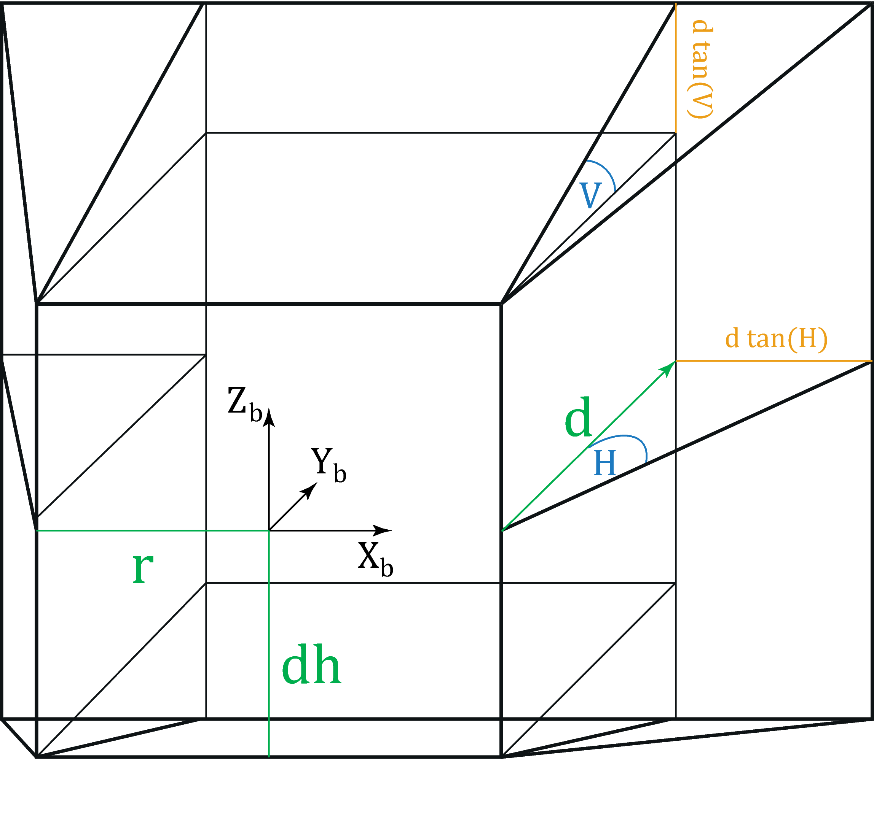

Fig. 4 Bounding box definition

The box is widened by the horizontal $H$ and vertical $V$ opening angles with a fixed depth $d$. In order to generate reference data for image-to-geometry, the lateral accuracy defined by the mobile positioning system as well as the provided camera characteristics solve for the mentioned parameters. For camera-based gauging, the depth is set to d = 200 m. Additional tiling of the 3D base data is advisable for a rapid geometry-in-frustum containment checks.

Using the defined frustum of a pyramid as region of interest with a local reference system, the image plane for 3D point rendering can be defined by perspective projection of the remote $xz$-plane (Fig. 4) with eq. 5 for the bounding box background plane, described by its upper left and lower right corner.

${\vec{X}}_{b_UL}= \left(\begin{matrix}-r-d\tan{H} \\ d \\ dh+d\tan{V}\end{matrix}\right)$, ${\vec{X}}_{b_LR}= \left(\begin{matrix}r+d\tan{H} \\ d \\ -dh-d\tan{V}\end{matrix}\right)$

(5)

The height equals the height component in the world reference frame $z_{w}$. Because of pyramid frustum, we subsequently eliminate points outside the near- and far clipping plane.

Pyramid approach for depth filtering

Because of a limited range of pixels with defined size inside an image plane it seems to be obvious that, in most cases, more than one 3D object points corresponds to the same image pixel. Due to inhomogeneous image coordinates it is not possible to figure out afterwards which points are in foreground compared to the camera distances and which ones are behind and thus not visible. This problem can easily be solved during point cloud projection described above by a simple camera-to-object distance check. However, one problem still remains in case of e.g. glass fronts with lacking information (in TLS due to deflection or SfM when having homogeneous surfaces) or small arches.

Scale-space image pyramids are a nice alternative approach to overcome the issue. This scale space is constructed from multiple synthetic images via step-by-step adjustment of $k⋅p_{s}$ (eq. 5) with k = 2, resulting in halve the number of image rows and columns per layer. Then, the algorithm verifies if two pixels correspond in two subsequent layers, preserving edges (see Fig. 5 for results).

|  |  |
| --- | --- |
|  |  |

Fig. 5 Obscured but visible 3D points close to arches and windows (l), edge preserving result after filtering (r).

Filling gaps due to missing points

Because of pixel size and image plane definition with a specific resolution (i.e. depending on smartphone full-scale camera's resolution for image registration purposes) there will still be gaps between the projected points.



Fig. 6 Fill image gaps using nearest neighbour binary search in 3D domain.

In order to fill these gaps, it is recommended to apply a simple nearest neighbour approach using binary search (Bentley, 1975) in the 3D domain to fill these gaps, applying weights to average 3D point colour attributes depending on their Euclidean distances. For this, thresholds for maximum distances between 3D points must be applied to avoid unreasonable gap-filling. Exemplary for luse case in section *Derivation of hydrological parameters*, a before-after comparison of the gap filling is shown in Fig. 6.

Image-to-geometry registration

Image-to-geometry algorithms aim at registering 2D images to a given 3D surface, providing a transformation from the 2D image coordinate system to 3D model coordinate system as follows:

$P^{'}∈ R^{3}= \left(\begin{matrix}u \\ v \\ w\end{matrix}\right)= \left[R_{3,3}\left|T_{1,3}\right.\right]⋅P$ with $P∈ R^{3}= \left(\begin{matrix}x \\ y \\ z\end{matrix}\right)$

(6)

with $R_{3,3}$– rotation matrix; $T_{1,3}$– translation vector

$P$– point of the object; $P'$– (projected) point of the image plane

$(u,v,w)$– image plane coordinates; $(x,y,z)$– world coordinates

Using this coordinate system transformation in combination with a known interior camera orientation, it is possible to project each image on the surface or vice versa.

Amongst the published literature, feature-based registration algorithms are most common. Here, salient points (e.g. SIFT, SURF, Harris corners, see (Mikolajczyk & Schmid, 2004) for details) or edges within the photograph and rendered image of the target 3D model are used to establish an image-to-image correlation.

In order to establish a 2D-3D correlation, there are two prevalent approaches available: for triangle mesh models, the 2D feature locations within the rendered image are raycasted using the virtual camera's vanishing point, the imaging plane, and the 3D surface model (Kehl, et al., 2016a), resulting in the correlated 3D coordinate of the 2D feature. An alternative approach is needed for point-based models because raycasting does not apply to point representations (i.e. points cannot be intersected directly due to their zero-extent). The alternative approach often applied, see (Sibbing, et al., 2013; Sattler, et al., 2011; Rodríguez, et al., 2012; García, et al., 2015), employs smart rendering techniques that virtually expand the point into an area feature (e.g. blob, disk or sphere), which is subsequently rendered into a depth map. Afterwards, the 3D coordinate of a 2D feature can be inferred directly from the depth map. Though smart utilising graphics technology, this approach is limited by an accuracy-to-speed trade-off: low-resolution and low-quantisation depth maps introduce artificial accuracy errors in the registration process, whereas high-resolution depth maps cost considerable performance in the image generation. This last point is particularly important when employing depth map algorithms on mobile devices.

Feature-based registration is the most common approach for establishing image-to-geometry correlation on mobile devices due to its implementation simplicity, its rapid execution speed, its option for application-specific constraints and the wealth of available code that can be used. Application examples are ample within the literature, ranging from augmented reality (Gauglitz, et al., 2014; Sweeney, et al., 2015) over field geology (Kehl, et al., 2016a; Kehl, et al., 2017b), to surface hydrology (Kröhnert & Meichsner, 2017; Boerner & Kröhnert, 2016). These mobile apps utilize the open-source library OpenCV4Android[1], which is also employed in this work[2]. Problems in real-world cases are caused by imaging variances, resulting in reduced reliability (i.e. failing to determine any camera parameters) and stability (i.e. determining different parameters for the same sets of images) (Kehl, et al., 2017a). A completely alternative technique to feature-based methods is Mutual Information (MI) (Viola & Wells, 1997; Corsini, et al., 2013). MI performs a pixel-wise comparison between the photo $I_{2D}$ and the 2D rendering of the 3D scene $I_{3D}^{'}$ and aims at minimizing the image discrepancies (i.e. $argminΔ\left(I_{2D}, I_{3D}^{'}\right)$). The technique uses information theory quantities such as self-information and entropy in order to compare the similarity of both image. In contrast to feature-based techniques, MI faces challenges in the optimization process: the optimization of a 7 degree-of-freedom equation system ($t_{x},t_{y},t_{z},ψ,φ,θ,f$, for $f$ being the focal length) is unstable and prone to rest in local function minima. Only few optimisation solvers are known that can solve such equation systems reliably and provide stable results - most notably NEWUOA, i.e. Powell's method (Powell, 2006) used by (Corsini, et al., 2013). None of the advanced solvers is available in modern- and mobile-device programming languages, thus the use of MI on mobile platforms is currently prohibited.

When 2D-3D point pairs are established, the coordinates are normalized and put into a least-squares optimization system, where the target is to determine the exterior camera parameters ($t_{x},t_{y},t_{z},ψ,φ,θ$) from the 2D-3D point-based equation system. Each time the camera of a mobile device is started, it has to be re-initialised. Furthermore, the more sensors are active, the device heats up rapidly affecting the in-built components. Consequently, the stability of inbuilt smartphone cameras is highly critical and thus their calibration (Kröhnert, et al., 2017). If enough well-distributed 2D-3D point pairs are provided, the intrinsic parameters $\left(f, c_{x}, c_{y}\right)$ and lens distortion can be refined, too. Non-linear optimisation systems (e.g. Levenberg-Marquardt) are applied to estimate the desired parameter set (Torr & Zisserman, 2000). The whole process can easily be executed on mobile devices (Kehl, et al., 2016a). One of the prevalent practical challenges when employing feature-based image-to-geometry registration is to achieve a reliable feature correlation, which is often achieved by introducing application-specific constraints (e.g. horizon alignment (Sánchez-García, et al., 2017) straight-edge enforcement or object outlines).

Sensors

What is the great difference between former mobiles and today's smartphones? Smartphones have many inbuilt sensors such as acceleration measurement units, compasses or gyroscopes, playing increasing rolls not only to have control over display or camera rotation. In the following we assess orientation accuracy and precision by applying different sensor fusion methods, which in their turn influence image-to-geometry registration. Furthermore, we give a short review over smartphones' positioning quality in relation to 3D annotations.

Localisation

Compared to the years 2008 and 2009, sales volume for navigation systems declined sharply and constantly by approximately 70 % compared to 2017 in Germany[3].One of the most important factors behind this may lie in the distribution of smartphones with inbuilt positioning systems, providing quite interesting alternatives to former navigation systems.

For this, most of today's smartphones are equipped with absolute Global Positioning System (GPS) receivers that are able to gather data from American GPS, Russian GLONASS and increasingly European GALILEO as well as Chinese BAIDOU. Even within the geosciences, smartphones gain more and more popularity e.g. for mobile mapping (Westhead, et al., 2013; Masiero, et al., 2016), or actually 3D reconstruction (Muratov, et al., 2016; Ishihara, et al., 2017).

Based on these facts, many research groups recently discussed the potential of smartphone localisation strategies whereby we want to focus on outdoor use cases based on Global Navigation Satellite Systems (GNSSs). (Blum, et al., 2013) observe the positioning for Android smartphone Samsung Galaxy Nexus and Apple Iphone 4 with different environmental conditions. Walking through the city they get lateral accuracies of about 10-15 m close to buildings no taller than three stories. Near skyscrapers, errors of about 30 m should be expected with local extremes up to 60 m. Similar things are published by (Fritsch, et al., 2011) who determined an overall accuracy for Android smartphone HTC Hero of 15-25 m valid in 95 % of cases which was also estimated by (Zhu, et al., 2013) and (Zandbergen & Barbeau, 2011). Exemplary for open spaces, (Meek, et al., 2013) observe an average GPS accuracy of 6.8 m using a Google Nexus S smartphone. However, height estimation seems to be more critical where (Liu, et al., 2014) name error margins for altitude determination using smartphone's inbuilt absolute GPS which seem to be 2.5 times more than the horizontal component and recommend the alternative usage of barometric approaches, providing height accuracies up to 3 m. Unfortunately, only a few of common smartphones have inbuilt barometers and reference data, necessary for barometric altitudes, is quite difficult to obtain.

Location sensitivity

Pre-knowledge about an image's position is a prerequisite for image-to-geometry registration. Thus, we are asking for how uncertainties affect the positioning accuracy for feature detection and furthermore the matching results. We observe the reliability of image matching using an initially manually registered image pair of a real and a virtually rendered image to observe their matching results when manipulating the image position. We change the lateral and height components in steps of 2.5 m up to a deviation of 25 m, respectively and observe the distribution of matched inlier. Fig. 7 shows the percentage of inliers whereas the maximum refers to the highest distribution.

Surprisingly, all components are rather equal affected by erroneous locations which rapidly leads to infeasible matchings when location differs more than 2.5 m/ 5 m (northing/easting). For height component, the results are quite unstable regarding inlier occurrences. Compared to the observed accuracies of smartphone inbuilt GNSS, the results refer to be non-negligible issues.

Fig. 7 Number of total inliers in [%] registering real and synthetic images manipulating users’ position with regards to height, northing and easting, respectively. Dashed lines refer to missing values in cases of failed matching.

Orientation

Nothing to say that low-cost sensor systems for orientation determination, as they are integrated in smartphones, may not have precision and stability compared to professional IMUs. Thus, we put forward the hypotheses that noise in smartphone sensor stability as well as their accuracies may not be in ranges comparable to navigation systems in autonomous navigation applications.

To give some basis, a smartphone orientation unit never depends on only one single sensor. It commonly consists of several components like accelerometers, magnetometers, gravity sensors or gyroscopes that measure in all three axes of the device. Due to single characteristics, sensors may complement each other’s, e.g. both, gyroscopes and accelerometers, measure the rotation of the smartphones in device-specific coordinate systems where gyroscopes are quite precise but suffer from drift effects. On the contrary, accelerometers are less sensitive for drifts but have poor signal-to-noise ratios. Applying sensor fusion helps to compensate for these negative characteristics in an ideal way.

Thus, Android divides sensors in two categories where, on the one hand, hardware sensors are true inbuilt components and on the other, virtual or soft sensors stand for fused hardware to generate a new synthetic sensor. That's why, when using e.g. Kalman filter approaches with different weights, more stability or accuracy can be given to smartphone's orientation.

(Pacha, 2015) presents two alternative virtual sensors additionally to Android's (Kalman-filtered) Rotation Vector (ARV)[4], where the Improved Orientation Sensor 1 (IOSens1) should be more precise than ARV but less stable whereas Improved Orientation Sensor 2 (IOSens2) seems to be less accurate but more robust. In the following, we check the three sensor types ARV, IOSens1 and IOSens2 for their stability and accuracy compared to an IMU that is commonly used for car and UAV navigation. For this, we compare measurements taken at three different times for the devices Google Nexus 5, Samsung Galaxy S8 and the IMU Spatial from the Australian company Advanced Navigation v6.1 that serves as ground truth (for sensor specifications refer to Table II[5] and Table III[6]).

Table II. Orientation sensor specifications for Google Nexus 5 and Samsung Galaxy S8.

|  |  |  |
| --- | --- | --- |
|  | Google Nexus 5 | Samsung Galaxy S8 |
| Accelerometer / Gyroscope | InvenSense MPU-6515 (6-axes) | ST Microelectronics LSM6DSL (6-axes) |
| Magnetic compass | Asahi Kasei AK8963 | Asahi Kasei AK09916C |
| Pricing | (-) | 6.50 USD |

Table III. IMU specifications/ accuracies for Advanced Navigation Spatial v6.1.

|  |  |  |  |  |  |
| --- | --- | --- | --- | --- | --- |
| Static | | Dynamic | | |  |
| Heading | Pitch/Roll | Heading  (with GNSS) | Heading  (magnetic only) | Pitch/Roll | Pricing |
| 0.5 ° | 0.1 ° | 0.2 ° | 0.8 ° | 0.2 ° | 3.500 USD |

Each measuring epoch comprises six parts. We assume that the sensors will show different behaviour when they are rigid or in motion. Furthermore, magnetic disturbances may influence the heading angle which mainly depends on the magnetic compass sensor. Additionally, we assume that results of sensors in rest may be slightly better when they are able to calibrate themselves after a short running time in motion. All observations are independent from each other, measured over time periods of more or less 02:30 min.

For comparison, smartphone and IMU are mounted on an inflexible non-metallic wooden stick at a distance of 1.0 m (to avoid mutual magnetic interferences) with aligned (native) coordinate systems (Fig. 8). Only for pitch angle the opposite direction of rotation must be kept in mind.



Fig. 8 Measurement setup to observe smartphone sensors accuracies and precisions. Heading around +/- z-axis pointing to/away from the sky, pitch around +/- x-axis pointing out of smartphone's display to the left, roll around y-axis pointing to true north when smartphone is lying on a flat desk.

In the following, orientation tracking for Samsung Galaxy S8 in comparison with the IMU is documented for the first observation period about 60 seconds with a sampling rate of 20 Hz and matched by UTC time every 0.1 s. The recorded values refer to the orientation angles (magnetic) heading, pitch and roll and are given in degrees. The related figures (Fig. 10, Fig. 11, Fig. 12) collectively use the same legend, which is given in Fig. 9.



Fig. 9 Legend.

|  |  |  |
| --- | --- | --- |
| Heading | Pitch | Roll |
|  |  |  |
|  |  |  |

Fig. 10 Observation of orientation angles measured from Samsung Galaxy S8 and the reference IMU. Both devices are in rest free from (top) and exposed to (bottom) magnetic disturbances.

|  |  |  |
| --- | --- | --- |
| Heading | Pitch | Roll |
|  |  |  |
|  |  |  |

Fig. 11 Observation of orientation angles (left to right: heading, pitch, roll) measured from Samsung Galaxy S8 and the reference IMU. Both devices are in rest after a short warm up (~ 30 s) free from (top) and exposed to (bottom) magnetic disturbances.

|  |  |  |
| --- | --- | --- |
| Heading | Pitch | Roll |
|  |  |  |
|  |  |  |

Fig. 12 Observation of orientation angles measured from Samsung Galaxy S8 and the reference IMU. Both devices are in constant movement free from (top) and exposed to (bottom) magnetic disturbances.



Fig. 13 Mean deviations between Samsung Galaxy S8 and Google Nexus 5 for heading, pitch and roll, respectively, use of IOSens1 & 2 (in graphic I1, I2) and ARV (in graphic K) sensor fusion.

Surprisingly, the results of all three virtual sensors of both smartphones show independently from each other almost the same behaviour as visualised in the figures above for Samsung Galaxy S8. Especially IOSens1 and ARV are very similar whereas IOSens2 seems to be slightly more stable, but at the same time more sensitive for drift issues as expected. Beside this, note that pitch and especially roll angles of both smartphones are close to the orientation of the reference, especially in comparison to the heading angle.

Fig. 13 visualises the mean deviations between the above-mentioned observations from Samsung Galaxy S8 as well as the repeated observation with Google Nexus 5. With respect to the deviations, a good agreement with related studies can be resolved. (Blum, et al., 2013) determined orientation errors up to 30 degrees for heading with significant drifts accelerating over $4.0 \frac{deg}{s}$ observed over several minutes. Similarly, (Kok, et al., 2017) show how magnetic disturbances affect all three orientation angles referring to the same errors of more than 30 degrees with regards to the heading angle, which is recognizable in our studies too. They also figured out that the heading accuracy is relatively low compared to roll and pitch, which are considered accurate. They justify the results with a worse signal-to-noise ratio of the magnetometer compared to that of the accelerometer and the local magnetic field vector, being commonly used for the compass direction that points to magnetic- instead of true north. In consideration to this, the magnetic field should have a major influence on the result of the heading angle, which is why the observations of rigid, rigid after warming up and moving smartphones were performed in both, a free and magnetic disturbed environment placing metallic objects and other interfering sources into the measuring environment. In our case, we use the magnetic field to compute true north by location-dependent declination adding to sensor's heading and thus correct heading pointing to true north as it appears for our reference IMU.

As visualised in the figures above, we cannot determine a higher frequency of deviations between the reference angles and the smartphone angles caused by magnetic influences. However, the reference may be similarly affected by magnetic disturbances which is further investigated.

Orientation stability

Focussing on the rigid measurements, sensor stability can be assessed by comparing standard deviations summarised over full observation period of 02:30 min for the reference IMU in relation to the smartphones Samsung Galaxy S8 and Google Nexus 5, respectively (Fig. 14). Except heading angle, both devices show very stable measurements for all virtual sensors with standard deviations less than 0.1 degrees, independently from the environment which might be free or full of sources affecting the magnetic field. In comparison to this, the standard deviation regarding heading angle raises up significantly having a magnetic-interfered environment.



Fig. 14 Observing orientation angles heading, pitch and roll when the devices Samsung Galaxy S8 and Google Nexus 5 are in rest, having an environment, free and full of magnetic disturbances (refer to sensor observation 1 and 2). Applying IOSens1 & 2 (in graphic I1, I2) and ARV (in graphic K) sensor fusion.

Surprisingly, angles belonging to sensor IOSens2 show higher discrepancies although they should be less accurate but more stable. Nevertheless, for all virtual sensors the results are comparable to others studies like (Fritsch, et al., 2011), who measured standard deviations over 20 samples for heading, pitch and roll of 1.0, 0.2 and 0.1 degrees respectively (using smartphone HTC Hero). Similar results are presented by (Meek, et al., 2013) for compass (heading) and tilt (pitch) angles referring to standard deviations of 5.1 and 0.75 degrees.

Including gyroscopes, heading is vulnerable for large drifts over time (Kok, et al., 2017), which is especially noticeable for the reference IMU. Also, the heading obtained by IMU seems to be rather susceptible to magnetic disturbances (Fig. 10, red lines). As mentioned in the beginning, sensor fusion can compensate negative impacts regarding sensor hardware. We have no information for filter algorithms used in Advanced Navigation Spatial v6.1, but for smartphone orientation determination the applied virtual sensors try to compensate this deficiency.

Orientation sensitivity

When we talk about the registration of 3D objects and 2D image data, it becomes obvious that similarities between virtual representations and the corresponding captured photos are of pivot importance. Key drivers for this are matching extrinsics due to the projection provisions. As shown above, positioning and orientation using smartphones may be a serious problem caused by incorrect exterior orientation leading to different image contents. Similarly to the research of location sensitivity, we investigate the matching results from a given image-to-object correspondence while manipulating the orientation in increments of 5 degrees turning clock- and counter-clockwise regarding heading, pitch and roll, respectively.

As shown in Fig. 15, changing the angles of heading and pitch is correlated with the number of matching feature points essential for camera estimation. Thus, the most critic heading angles can vary in range of [-40, 40] degrees. A similar picture emerges when assessing the angles for pitch, which can change in range of [-25, 25] degrees. If these limits are exceeded, the camera only sees the sky or the ground (for pitch) or looks in a completely wrong (compass) direction (regarding heading). Compared to these two angles, the roll angles show a different behaviour. For image matching we chose the (rotation and) Scale Invariant Feature Transform (SIFT) descriptor (Lowe, 2004) and thus, changing the roll angle does not have major influence on the outcome.

Compared to sensor accuracy measurements, the results give a comfortable feeling using smartphone sensor fusion for the determination of approximate orientation where pitch and roll show maximum errors up to 7.4 and 5.3 degrees. However, for heading there could be significant problems ahead showing errors of more than 30 degrees, as mentioned before.

Fig. 15 Number of total inliers in [%] registering real and synthetic images manipulating the orientation with regards to heading, pitch and roll, respectively. Dashed lines refer to missing values due to failed matching.

Power consumption

Power consumption is an important metric for mobile field applications, which is at the same time also distinct to the mobile device platform. This metric governs the operation time of an app in an outdoor field setting. In application domains such as field geology, the target operation time is in the range of four to eight hours without device recharging. The original operation time can be extended with external battery packs, although there is a limit of how many battery packs can be taken into the field before their total weight renders the mobile device impractical as a field tool.

We measured the energy consumption of the Android applications (hereinafter referred to as apps) “Open Water Levels” (OWL) and “Geological Registration and Interpretation Toolset” (GRIT) in realistic settings for case studies in water line detection, as ground work for camera-based water level observation, and field interpretation. Both apps are further outlined in section *Applications*. Measuring the power consumption on an app-specific level is not supported by default on mobile devices. Formerly, the power consumption has only been assessed on a hardware component level (Carroll & Heiser, 2010). This study utilised the App “Trepn Profiler”[7], which is currently the only known app that facilitates app-specific measurements. Trepn Profiler also allows for the simultaneous logging of technical indicators (e.g. GPU- and Central Processing Unit (CPU) load, memory consumption, CPU temperature), which is used in this study to draw higher-level conclusions on the utilisation of the apps. The presented measurements were obtained on a Google Nexus 5 smartphone.

Our tests involve the quantification of energy consumption contribution from application-specific tasks that relate to CPU- and GPU usage. GPU usage is mostly related to image-space operations in 2D, such as the image presentation and image-related operations (e.g. waterline and geological boundary delineation). In 3D, the GPU is responsible for 3D base data rendering and on-device image-to geometry registration. The CPU is responsible for the all non-graphical tasks as well as data loading, photo capturing and mobile sensor management. The dependency of power consumption, CPU- and GPU load is shown in Fig. 16 and Fig. 17.

In both apps, a clear dependency with CPU load and power consumption is observable. In OWL, one can observe the reoccurring “double-hump” series within CPU process and power consumption, whereas GRIT displays a more irregular peak distribution with direct correlations. We can therefore conclude that the mobile processors adapt their clock frequency when less operations are performed, which leads to a reduced power consumption. When comparing CPU- and GPU-related states, we conclude that while the CPU drives the average power consumption, the GPU (being used for rendering images and annotations within them) drives the peak power consumption.

Fig. 16 visualises the relationship of power consumption, CPU, as well as GPU for 2D data processing in OWL. For water line detection, a spatio-temporal texture must be calculated using time lapse images (details are given in (Kröhnert & Meichsner, 2017)). Thus, the CPU load locally rises and falls significantly for each single frame processing (here 15 peaks for 15 images). Unlike CPU behaviour, GPU load is steadily increasing while storing each co-registered image. After image processing, both CPU as well as GPU load are released whereas app modifications via the user interface leads, as expected, once more to higher loads.

When comparing the 2D and 3D operations, visualised in Fig. 17, the 3D operations result in an additional energy cost, raising the average power consumption by 100.6 [$\frac{mA}{h}$]. In contrast to novice expectation, the CPU load also increases in a 3D data processing setting because the main processors deliver the geometric- and texture data to the GPU. Additionally, the CPU needs to decompress the image textures, resulting in a higher processing load.

The conclusions of this power consumption study for field apps are manifold. We obtained benchmark measurements for specific target apps in hydrology (OWL) and geology (GRIT), and explain how to replicate the study on Android devices with other field apps in the future. For OWL, the app can be operated on an average of 1090.41 [$\frac{mA}{h}$], resulting in an operation time of 2.11 hrs on the Google Nexus 5.

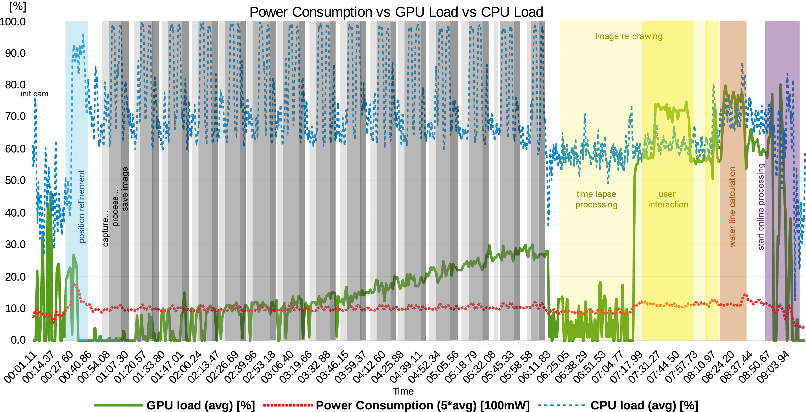

Fig. 16 Integrated diagram of power consumption, CPU & GPU load of OWL in 2D mode.



1. Integrated diagram of power consumption, CPU- & GPU load of GRIT in 2D mode.



1. Integrated diagram of power consumption, CPU- & GPU load of GRIT in 3D mode.

Fig. 17 Particular operations, such as image rendering and interpretation editing, are interpreted within the bands as they result in a distinct CPU-GPU behaviour.

For GRIT we have to distinguish between the mode in which it is operated: when conducting 2D operations, the operation time amounts to 4.68 hrs but when making full use of the 3D capabilities, the average power consumption rises and results in an operation time of only 3.88 hrs. Key measures on power consumption, and related metrics of processor temperature and memory usage, are given in Table III for both applications.

However, we highlight these measurements as being the *theoretical* operation time because most users have other apps and background services open on their mobile device that simultaneously consume power, further reducing the operation time. Lastly, as stated by (Carroll & Heiser, 2010), the app-specific consumption (in particular with “visual apps” and the sensor applications) also depends on the screen brightness and the sensor usage.

In more general terms, the study shows that application domain practitioners need to be aware of what data they are dealing with in order to get the maximum operation time and most efficient workload done during the field study. This will have implications for fieldwork planning for expert users and practitioners, as they can modify their study plan to first collect photos and observations from several viewpoints of their study objective and then use 3D operation features “in burst” for visual checks and data interrogation before moving on to the next subsequent study locations. Insufficient planning and an overuse of 3D field app features can reduce the effective “digital fieldwork” time using GRIT to 7.70 hrs at best when carrying one external battery pack.

Table IV Average measurements of GRIT and OWL using Google Nexus 5.

|  |  |  |  |
| --- | --- | --- | --- |
|  | GRIT (2D) | GRIT (3D) | OWL (2D) |
| power consumption | 491.44 [$\frac{mA}{h} 3.6 V$] | 592.04 [$\frac{mA}{h} 3.6 V$] | 1090.41 [$\frac{mA}{h}$] |
| memory usage (avg.) [GB] | 1.75 | 1.72 | 1.54 |
| temperature [°C] | 49.91 | 52.05 | 58.55 |

Applications and Requirements

Use cases and application scenarios within the geosciences emerged recently for mobile technology due to the increasing usability of mobile devices for field studies. In the following, two key applications are presented: water level gauging through field observations for small and medium-sized catchments and geological interpretation of sedimentary features in field geology.

Derivation of hydrological parameters: Water level gauging

The past decade is characterized by a continued increase of globally devastating flash floods after heavy rainfalls. Even smallest creeks turned into hazardous streams resulting in floods and landslides. Conventional gauging stations provide precise information about water levels measured over short time periods. Because of high costs in purchase and maintenance, gauging stations with their complex sensing devices must be sparsely installed. Thus, many creeks and rivers are not monitored neither during flood events when the most protection is required. Recently, commercial smartphone applications arose to provide tools for crowd sourcing-based water level estimation, e.g. (Kisters, 2014; Etter & Strobl, 2018). All of them have one thing in common: the water level is entered manually by engaged citizens who photograph tide gauges close to rivers that presents potential danger to themselves. Beside this, the technique is still limited to open and visible pre-installed gauges.

Improvements can be achieved by the registration of situation-dependent images to 3D point surfaces for automatic water level determination on running waters without requiring reference gauges. For this, the Android application OWL is developed, which uses the freely available open source framework *Open Camera*[8]. Put it in a nutshell, with the aid of short, handheld time-lapse image sequences, captured by smartphone cameras, the water line can be processed on the device (Kröhnert & Meichsner, 2017) and subsequently registered with existing 3D object data to obtain the corresponding height values, i.e. water levels.

As figured out in section *Sensors*, a good approximation of extrinsic parameters is a basic prerequisite for successful 3D annotation whereby precision and stability is strongly correlated with measuring environment. Especially magnetic perturbations affect the user's orientation, and can represent a special problem. The issue can be circumvented for stationary perturbation sources by re-calibration of magnetic sensors just before the measurement, as it is often being done for advanced car navigation. Unfortunately, the magnetic strengths attaching the phone may change substantially in short time especially in natural or urban environments. As described above, image-to-geometry registration is very error-prone for inaccurate exterior parameters except roll angle. The reason for this lies in rendering a synthetic image from coloured 3D reference point clouds using a person's location and orientation. Thereby, heading and pitch mainly define the depth direction, incorrect angles provide a false viewing direction resulting in a synthetic image that has little-to-no similarity with the time lapse sequence. Consequently, the water level detection will fail or give false results caused by adverse inlier distribution in image matching that impedes a correct positioning (e.g. lacking overlap). Thus, inbuilt GNSS receivers should be considered as another major source of error for 3D annotation. In urban scenes with several shadow effects due to high-rise buildings, as well as in situations of heavy cloud coverage, errors of several metres in latitude and up to more than 30 metres in altitude are highly possible. However, assistance is provided by external data sources. OWL provides the possibility of user supported position refinement invoking Google Maps[9] and height optimisation using the underlying DEM data. It is very likely that, in the near future, smartphone GNSS modules are rolled out, solving lateral accuracies of 50 cm (Moore, 2017). Thus, having internet connection is indispensable but not a problem in urban environments. It is worth mentioning that UMTS/LTE are furthermore needed to enable online water line processing after transmitting a compressed package containing the master image, the derived water line in 2D space and some meta data to describe the prevalent object scene.

For now, an issue is the availability of free available 3D representations captured close to rivers with focus on shore environment. However, first attempts from Google Street View to cover near shore environments by river cruises are published[10]. In the future, this option is expected to expand to other rivers on a global scale. Furthermore, some research projects deal with autonomous river crossing to acquire hydrological parameters as well as shore land information in short timespans (Sardemann, et al., 2018). Thus, 3D point sets can be acquired very fast (e.g. using mobile laser scanning or SfM) covering the same place at different times to deal with multiple representations caused by season-dependent vegetation, snow coverage or changed illumination due to the ambient conditions at specific times of the day.

Field geology

The goal of geological fieldtrips is to gather insight in the rock record and the structural- and sedimentary rock architecture of a given location. Rock architecture can be studied within subsurface seismic records, but this approach suffers from inferior imaging (seismic) resolutions and physical limitations of the surveying technique. Therefore, surface outcrops are used for the study. Outcrops can be scanned with modern equipment (e.g. (Buckley, et al., 2008; Buckley, et al., 2010) and SfM (Chandler & Buckley, 2016), inter alia with UAVs (Dewez, et al., 2015)) to generate digital surface representations. The most common representations of digital outcrops are coloured point clouds and textured TINs.

The geological aspect is introduced by interpreting the outcrop models. In this case, interpretations refer to (i) line marks for separating stratigraphic layers, (ii) surface-projected polygons to highlight structural- and sedimentary facies or specific architectural elements and (iii) minor ticks (e.g. lines, points, patterns) to indicate supplementary attributes such as deposition orientation or grain geometry. The interpretations were, until recently, performed in a two-step process: sketches are drawn by hand in a dedicated field book to document the geologist's observations. After the fieldtrip, the observations are digitised in the office by transferring the sketched architecture on the available digital outcrop. From there on, further study goals (e.g. geomodelling) are pursued. As recently published, this workflow is currently being transformed into an integrated digital workflow in the field using mobile devices (see (Kehl, et al., 2018) for further details).

Geological interpretations can be documented on various scales while most observations are conducted on medium-range. This results in an average observation distance for architectural interpretations of between 100 m to 500 m to document individual depositional elements, and further distances of around 400 m to 1400 m to document the overall stratigraphic framework of an outcrop. These distances can vary depending on the physical accessibility of an outcrop. Therefore, and as a result of perspective observations, the required lateral localisation accuracy is in the range of $≤$ 2.5 m for the individual element setting and ≤ 8 m for the wide-angle stratigraphic setting. While achieving the former resolution can still be challenging with mobile sensors, the latter resolution is almost guaranteed for GPS localisation. The more important problem is in the vertical resolution: the vertical position has, especially on close distance, a drastic impact on the view perspective. Even more important, a vertical localisation error of $≥$ 1.5 m may result in positioning the mobile device ''under ground'', making any image-based registration impossible. Several improvements, such as DEMs and barometric altitude (Kehl, et al., 2017b), have been proposed to reduce the vertical positioning error. Despite the proposed improvements, there is still room for novel research proposals to provide more accurate vertical positioning or ground-based constraints on the altitude estimation.

One particular challenge in digital field geology is the treatment of environmental changes. Digital outcrops are infrequently collected and the textured models are used for field study all across the year. Therefore, in image registration terms, there is a drastic difference in local illumination, moisture content as well as fog and snow between acquired 3D surface models and the outcrop images collected during field trips. The issue has been previously discussed in terms of illumination differences (Kehl, et al., 2017a), but drastic changes in terms of fog and moisture remain challenging for auto-registration algorithms. Therefore, it is advisable to collect digital outcrop models for prominent locations in different seasonal conditions to allow for variety in model selection when planning actual field trips.

Currently available systems that provide digital outcrop interpretation capabilities on mobile devices in 3D include GRIT (Kehl, et al., 2016b) and Outcrop (Viseur, et al., 2014), though earlier prototypes have been demonstrated (Hama, et al., 2013). Outcrop, developed by Centre Européen de Recherche et d'Enseignement des Géosciences de l'Environnement (CEREGE) at Aix-Marseille Université, is an app that is able to load and process various forms of numerical outcrops. Its major focus is the documentation of structural features (e.g. fault areas, fractures and rock deformations) on outcrops using line interpretations. Furthermore, it is possible to pin notes to points within the model. GRIT, developed as a collaboration between Uni Research AS CIPR, University of Bergen, University of Aberdeen and CEREGE, is an app that can handle large-area digital outcrops of tens of kilometres in surface length in 3D. Its major focus is the documentation of the sedimentary- and stratigraphic architecture (e.g. strata boundaries, depositional object envelopes, facies areas) on outcrops via lines, polygons and brushes. The interpretations are mapped in a 2D-3D interplay between outcrop surface and field photograph (Fig. 18).

|  |  |
| --- | --- |
| (a) GRIT | (b) Outcrop |

Fig. 18 Visual comparison between two 3D mobile apps for DOM interpretation, namely GRIT (a) and Outcrop (b), with a model of the Calvisson quarry. Images taken from (Kehl, 2017c).

Conclusions and Discussion

This article addresses challenges for employing mobile devices and digtal tools for outdoor field studies within the geosciences with a special focus on 3D surface utilisation. Due to the research effort in recent years, novel mobile applications such as OWL for surface hydrology and GRIT for field geology were introduced to the community to bridge the gap between lab assessment and outdoor field work for data annotation and interpretation. This article also showed further application areas that build upon mobile device technology and the interactive annotation of 3D surface data for geoscientific problem solving.

(McCaffrey, et al., 2005) proposed the use of mobile devices for field interpretation in geology. The technological specifics of mobile device app development hampered the progress on this goal for years - for geology as well as other branches of the geosciences. Only recent advancements in efficient treatment of 3D data (Kröhnert, et al., 2017), algorithmic proposals for image-to-geometry registration (see (Gauglitz, et al., 2014; Kehl, et al., 2017b) and on-device 3D rendering (as presented in (Agus, et al., 2017) and in this article for point-based surfaces) specifically designed for mobile devices, enable professional field use of the apps. The utilisation of crowdsourced VGI and the introduction of mobile devices as low-cost measuring devices for real-world problems (Eltner, et al., 2017) contribute to the acceptance of this mobile device technology within the geoscientific community. Computer Vision challenges such as image registration under changing illumination conditions and with reduced image resolution can be viewed as ''sufficiently solved`` to make photogrammetric- and vision-based algorithms applicable to real-world outdoor settings, while still leaving space for improvement in quality and performance. Potentially significant improvement will be achieved in the future when an increasing number of advanced algorithms in numerics, graphics and vision (e.g. NEWUOA (Powell, 2006), out-of-core rendering (Borgeat, et al., 2005), MI (Viola & Wells, 1997) are ported to mobile platforms. This allows realising the most state-of-the-art techniques on mobile devices that require the additional precision and performance, instead of being limited by the small function collections currently available.

The measurements presented in this article as well as its related studies suggest that localisation and orientation of mobile device sensors with respect to the application-specific accuracy requirements is a persisting challenge. The sensors employed by low-cost devices have accuracy limitations. Sensor fusion techniques are required to even moderately consider the use of sensor data with complementary characteristics to solve for initial exterior smartphone camera orientation. Beside this, environmental effects such as device-internal heating processes and the system-internal handling of sensor initialisation further complicate the calibration of such sensors as well as the camera, impeding camera calibration prior to the intended application. Both issues can be solved using the registered 2D image and 3D object data with well-distributed feature correspondences to perform single image self-calibration during image annotation.

Furthermore, this study gives an overview about the energy consumption of mobile apps employing 3D surfaces, computer vision and computer graphics procedures. It was shown that the distinction between 2D- and 3D data used by mobile apps significantly drives the power consumption, and therefore the operation time of the mobile field apps during a study.

Regarding the presented apps, namely OWL and GRIT, both software applications are working on different data structures but, in the end, utilise the same process -namely image-to-geometry registration and user-selected corner point surface intersection- to generate surface-based annotations and interpretations. A persisting challenge with respect to the relation between power consumption and sensor accuracy is the user feedback: it is currently rarely possible to guarantee the user a correct pose estimation for his base photo, be it individual image or time lapse, upon which annotations and interpretations are done. On mobile devices, it is important to provide the software user early (visual) feedback about the prospective success and quality, so that potential image capture repetitions can be decided early. This is also in the interest of power conservation on mobile devices by only expending computing power where necessary

Regarding the main audiences of both apps, GRIT was designed for experts equipped with professional hardware far away from common smartphone equipment, allowing for heavyweight 3D processing on selected devices. On the contrary, OWL can be considered as low-cost approach designed for situation-dependent densification of hydrological water level networks using VGI. Consequently, OWL has to be operable on various (low-cost) customary phones utilizing the internet to outsource heavyweight processes, i.e. 3D processing and image-to-geometry registration, thus opening the door for a large audience. Hereby, the availability of mobile network, especially in inhabited areas, is not considered as an issue.

Lastly, the treatment of vegetation within scanned- and photographed data during mobile field studies remains a challenge in the context of interactive interpretation. 3D reference data are obtained less frequent than they are used in a given outdoor setting. Vegetation itself is visually dynamic content that complicates image registration to existing 3D data, which complicates interpretations in common outdoor settings. While current procedures of data processing try to segment and remove vegetation data from scans, it leaves the mobile device app with less information to work with when registering photos. Therefore, proposing means of 3D topographic data processing that homogenizes vegetation in 3D scans and photos without removing the related data will have an impact on accurate outdoor photo registration on 3D base data.

Acknowledgements

First, we would like to thank M.Sc. Richard Boerner from TU Munich, Germany for his assistance with the development of an alternative approach for synthetic image generation using perspective 3D-to-2D image projection with respect to object space definition and to solve for point occlusions (see section *A novel approach to mobile point-based rendering*). Furthermore, we want to graduate the European Social Fund and the Free State of Saxony for their financial support (funding no. 100235479). Aspects of this work were funded by the Research Council of Norway (RCN) and the FORCE consortium (Petromaks 2 project 234111).

References

Agus, M. et al., 2017. *Mobile Graphics.* s.l., The Eurographics Association.

Bentley, J. L., 1975. Multidimensional binary search trees used for associative searching. *Communications of the {ACM},* 9, Band 18, pp. 509-517.

Blum, J. R., Greencorn, D. G. & Cooperstock, J. R., 2013. *Smartphone Sensor Reliability for Augmented Reality Applications.* Berlin, Springer Berlin Heidelberg, pp. 233-248.

Boerner, R. & Kröhnert, M., 2016. *Brute Force Matching Between Camera Shots and Synthetic Images from Point Clouds.* s.l., s.n., pp. 771-777.

Borgeat, L. et al., 2005. GoLD: Interactive Display of Huge Colored and Textured Models. *ACM Trans. Graph.,* 7, Band 24, pp. 869-877.

Buckley, S. J., Howell, J. A., Enge, H. D. & Kurz, T. H., 2008. Terrestrial laser scanning in geology: data acquisition, processing and accuracy considerations. *Journal of the Geological Society,* Band 165, pp. 625-638.

Buckley, S. J. et al., 2010. Combining Aerial Photogrammetry and Terrestrial Lidar for Reservoir Analog Modeling. *Photogrammetric Engineering & Remote Sensing,* Band 76, pp. 953-963.

Carroll, A. & Heiser, G. e. a., 2010. *An Analysis of Power Consumption in a Smartphone..* s.l., s.n., pp. 21-21.

Caumon, G., Gray, G., Antoine, C. & Titeux, M. O., 2013. Three-Dimensional Implicit Stratigraphic Model Building From Remote Sensing Data on Tetrahedral Meshes: Theory and Application to a Regional Model of La Popa Basin, NE Mexico. *IEEE Transactions on Geoscience and Remote Sensing,* 3, Band 51, pp. 1613-1621.

Chandler, J. H. & Buckley, S. J., 2016. Structure from motion (SFM) photogrammetry vs terrestrial laser scanning. In: M. B. Carpenter & C. M. Keane, Hrsg. s.l.:American Geosciences Institute (AGS).

Corsini, M. et al., 2013. Fully Automatic Registration of Image Sets on Approximate Geometry. *International journal of computer vision,* Band 102, pp. 91-111.

Dewez, T. J. B., Leroux, J. & Morelli, S., 2015. *UAV sensing of coastal cliff topography for rock fall hazard applications.* s.l., s.n.

Eltner, A., Sardemann, H., Kröhnert, M. & Schwalbe, E., 2017. *Camera based low-cost system to monitor hydrological parameters in small catchments.* s.l., s.n., p. 6698.

Etter, S. & Strobl, B., 2018. *CrowdWater.* s.l.:s.n.

Fritsch, D., Khosravani, A. M., Cefalu, A. & Wenzel, K., 2011. *Multi-sensors and multiray reconstruction for digital preservation.* s.l., s.n., pp. 305-323.

García, S., Pagés, R., Berjón, D. & Morán, F., 2015. *Textured Splat-based Point Clouds for Rendering in Handheld Devices.* New York, NY, USA, ACM, pp. 227-230.

Gauglitz, S. et al., 2014. Model Estimation and Selection Towards Unconstrained Real-Time Tracking and Mapping. *Visualization and Computer Graphics, IEEE Transactions on,* Band 20, pp. 825-838.

Goesele, M. et al., 2007. *Multi-view stereo for community photo collections.* s.l., s.n., pp. 1-8.

Hama, L., Ruddle, R. A. & Paton, D., 2013. *3D Mobile Visualization Techniques in Field Geology Interpretation: Evaluation of Modern Tablet Applications.* s.l., s.n.

Ishihara, T., Vongkulbhisal, J., Kitani, K. M. & Asakawa, C., 2017. *Beacon-Guided Structure from Motion for Smartphone-Based Navigation.* s.l., s.n., pp. 769-777.

Jordan, C., 2009. SIGMAmobile: the BGS digital field mapping system in action: in the United Arab Emirates. *British Geological Survey.*

Kehl, C., 2017c. *Visual Techniques for Geological Fieldwork using Mobile Devices,* s.l.: s.n.

Kehl, C. et al., 2016a. Direct Image-to-Geometry Registration Using Mobile Sensor Data. *ISPRS Annals of Photogrammetry, Remote Sensing \& Spatial Information Sciences,* Band 3, pp. 121-128.

Kehl, C. et al., 2017a. Automatic illumination-invariant image-to-geometry registration in outdoor environments. *The Photogrammetric Record,* 6, Band 32, pp. 93-118.

Kehl, C. et al., 2017b. Mapping field photos to textured surface meshes directly on mobile devices. *The Photogrammetric Record,* 12, Band 32, pp. 398-423.

Kehl, C. et al., 2016b. *Geological Registration and Interpretation Toolbox (GRIT): A Visual and Interactive Approach for Geological Interpretation in the Field.* s.l., s.n., pp. 59-60.

Kehl, C. et al., 2018. Interpretation and mapping of geological features using mobile devices in outcrop geology - A case study of the Saltwick Formation, North Yorkshire, UK. *AGU Books - Special Issue.*

Kisters, 2014. *Einfach smart: App für Pegelmessung auf Knopfdruck.* s.l.:s.n.

Kok, M., Hol, J. D. & Schön, T. B., 2017. Using Inertial Sensors for Position and Orientation Estimation. *CoRR.*

Kröhnert, M., Kehl, C., Litschke, H. & Buckley, S. J., 2017. *Image-to-Geometry Registration on Mobile Devices - Concepts, Challenges and Applications.* s.l., s.n., pp. 99-108.

Kröhnert, M. & Meichsner, R., 2017. Segmentation of environmental time lapse image sequences for the determination of shore lines captured by hand-held smartphone cameras. *ISPRS Annals of the Photogrammetry, Remote Sensing and Spatial Information Sciences,* Band IV-2/W4, pp. 1-8.

Leskens, J. G. et al., 2015. An interactive simulation and visualization tool for flood analysis usable for practitioners. *Mitigation and Adaptation Strategies for Global Change,* pp. 1-18.

Letortu, P. et al., 2017. Examining high-resolution survey methods for monitoring cliff erosion at an operational scale. *GIScience & Remote Sensing,* 12.pp. 1-20.

Liu, G. et al., 2014. *Beyond horizontal location context: measuring elevation using smartphone's barometer.* s.l., ACM Press.

Lowe, D. G., 2004. Distinctive Image Features from Scale-Invariant Keypoints. *International Journal of Computer Vision,* 01 11, Band 60, pp. 91-110.

Masiero, A. et al., 2016. Toward the use of smartphones for mobile mapping. *Geo-spatial Information Science,* Band 19, pp. 210-221.

McCaffrey, K. J. W. et al., 2005. Unlocking the spatial dimension: digital technologies and the future of geoscience fieldwork. *Journal of the Geological Society,* Band 162, pp. 927-938.

Medjkane, M. et al., 2018. High-resolution monitoring of complex coastal morphology changes: cross-efficiency of SfM and TLS-based survey (Vaches-Noires cliffs, Normandy, France). *Landslides,* 1.

Meek, S., Priestnall, G., Sharples, M. & Goulding, J., 2013. Mobile capture of remote points of interest using line of sight modelling. *Computers & Geosciences,* 3, Band 52, pp. 334-344.

Mikolajczyk, K. & Schmid, C., 2004. Scale & affine invariant interest point detectors. *International journal of computer vision,* 1(60), pp. 63-86.

Moore, S. K., 2017. Superaccurate GPS Coming to Smartphones in 2018. *IEEE Spectrum,* 10.

Mueller, E. N. & Pfister, A., 2011. Increasing occurrence of high-intensity rainstorm events relevant for the generation of soil erosion in a temperate lowland region in Central Europe. *Journal of Hydrology,* Band 411, pp. 266-278.

Muratov, O. et al., 2016. *3DCapture: 3D Reconstruction for a Smartphone.* s.l., s.n., pp. 893-900.

Pacha, A., 2015. *Sensor Fusion for Robust Outdoor Augmented Reality Tracking on Mobile Devices.* USA: GRIN Verlag.

Ponchio, F. & Dellepiane, M., 2016. Multiresolution and fast decompression for optimal web-based rendering. *Graphical Models,* Band 88, pp. 1-11.

Powell, M. J. D., 2006. The NEWUOA software for unconstrained optimization without derivatives. In: *Large-scale nonlinear optimization.* s.l.:Springer, pp. 255-297.

Rodríguez, M. B. et al., 2012. *Interactive exploration of gigantic point clouds on mobile devices.* s.l., s.n., pp. 57-64.

Sánchez-García, E., Balaguer-Beser, A. & Pardo-Pascual, J., 2017. C-Pro: A coastal projector monitoring system using terrestrial photogrammetry with a geometric horizon constraint. *ISPRS Journal of Photogrammetry and Remote Sensing,* Issue 128, pp. 255-273.

Sardemann, H., Eltner, A. & Maas, H.-G., 2018. *Erfassung von Geometriedaten kleiner Flüsse mit einem unbemannten Wasserfahrzeug als Multisensor-Plattform.* Hamburg, s.n., pp. 389-396.

Sattler, T., Leibe, B. & Kobbelt, L., 2011. *Fast image-based localization using direct 2D-to-3D matching.* s.l., IEEE.

Schwalbe, E. & Maas, H.-G., 2017. The determination of high-resolution spatio-temporal glacier motion fields from time-lapse sequences. *Earth Surface Dynamics,* 12, Band 5, pp. 861-879.

Sibbing, D., Sattler, T., Leibe, B. & Kobbelt, L., 2013. *SIFT-Realistic Rendering.* s.l., s.n., pp. 56-63.

Siedschlag, S., 2015. *Wasserstände und Durchflüsse - Messen, Speichern und Übertragen im digitalen Zeitalter.* s.l., s.n.

Sweeney, C. et al., 2015. *Efficient Computation of Absolute Pose for Gravity-Aware Augmented Reality.* s.l., s.n., pp. 19-24.

Torr, P. H. S. & Zisserman, A., 2000. MLESAC: A New Robust Estimator with Application to Estimating Image Geometry. *Computer Vision and Image Understanding,* Band 78, pp. 138-156.

Trinks, I. et al., 2005. Mapping and analysing virtual outcrops. *Visual Geosciences,* Band 10, pp. 13-19.

Viola, P. & Wells, W. M., 1997. Alignment by maximization of mutual information. *International journal of computer vision,* Band 24, pp. 137-154.

Viseur, S. et al., 2014. *3D interactive geological interpretations on digital outcrops using a touch pad.* s.l., s.n.

Watanabe, Y. & Kawahara, Y., 2016. UAV Photogrammetry for Monitoring Changes in River Topography and Vegetation. *Procedia Engineering,* Band 154, pp. 317-325.

Westhead, R. K. et al., 2013. Mobile spatial mapping and augmented reality applications for environmental geoscience. *Journal of Internet Technology and Secured Transactions,* Band 2, pp. 185-190.

Wu, C., 2013. *Towards Linear-Time Incremental Structure from Motion.* s.l., s.n., pp. 127-134.

Zandbergen, P. A. & Barbeau, S. J., 2011. Positional Accuracy of Assisted GPS Data from High-Sensitivity GPS-enabled Mobile Phones. *Journal of Navigation,* 6, Band 64, pp. 381-399.

Zhu, X., Li, Q. & Chen, G., 2013. APT: Accurate outdoor pedestrian tracking with smartphones. *2013 Proceedings IEEE INFOCOM,* pp. 2508-2516.

*Résumé*

L’histoire de l’appariement d’images remonte à plus de cinquante ans, lorsque les premières …

Zusammenfassung

Infolge der rasanten technischen Smartphone-Entwicklung stellt sich die Frage, ob Smartphones nunmehr für den wissenschaftlichen Einsatz attraktiv sind. Ausgestattet mit umfassender Sensorik zur Positions- und Orientierungsbestimmung, Kameras sowie leistungsfähigen Prozessoren, scheinen Smartphones prädestiniert für die feld-basierte Datenakquisition, -prozessierung und -analyse.

Der vorliegende Artikel stellt zwei (Android) Anwendungen mit hydrologischem sowie geologischem Hintergrund vor, welche zur Annotation von 3D-Objekt- via 2D-Bilddaten dienen. Beide verwenden jedoch unterschiedliche, hier beschriebene, Vorgehensweisen um einerseits colorierte 3D-Punktwolken, andererseits Oberflächenmodelle mit Smartphone-Aufnahmen zu registrieren. Dazu sind Informationen über die innere sowie äußere Kameraorientierung unerlässlich, weshalb das Potential von handelsüblichen Smartphone Sensoren zur Bestimmung von Position und Orientierung erörtert wird. Darin inbegriffen ist die Analyse verschiedener Sensor Fusion Ansätze zur Ermittlung präziser sowie stabiler Orientierungsdaten. Der entscheidende Vorteil von Smartphones als Messinstrument und digitales Arbeitsgerät gegenüber konventionellen Systemen liegt in deren Mobilität. Nahezu alle Verarbeitungsschritte, angefangen von der Datenakquisition bis hin zur Informationsdarstellung können im Feld erfolgen. Die Batterielaufzeit ist somit eine nicht zu vernachlässigende Komponente, deren Verhalten bezüglich 2D- sowie 3D-Prozesse anhand der genannten Applikationen analysiert wird. Abschließend lässt sich die Einsatzfähigkeit aktueller, handelsübliche Smartphones für geowissenschaftliche Fragestellungen klären und bewerten.

Resumen

La correspondencia de imágenes tiene una historia de más de 50 años, desde los primeros …

摘要

影像匹配技术在模拟摄影测量中首次应用开始，已经有50年的发展 …

1. OpenCV4Android 2.4.10 - https://opencv.org/platforms/android
2. OpenCV4Android extensions - https://github.com/CKehl/opencv4Android_extension
3. Statista (accessed 2018-04-25) *Survey: Sales development in Germany for navigation systems since 2005* https://de.statista.com/statistik/daten/studie/3902/umfrage/entwicklung-der-verkaufszahlen-von-navigationsgeraeten-seit-2005/
4. Android developers guidance (accessed 2018-04-25) *Sensor event values* https://developer.android.com/reference/android/hardware/SensorEvent.html\#values
5. Specifications for Samsung Galaxy S8 and Google Nexus 5 (both accessed 2018-04-25) https://technology.ihs.com/api/binary/592077, https://de.ifixit.com/Teardown/Nexus+5+Teardown/19016
6. Specifications for Advanced Navigation Spatial v6.1 (accessed 2018-04-25) http://www.advancednavigation.com.au/product/spatial\#specifications
7. Trepn Profiler (accessed 2018-04-29) https://developer.qualcomm.com/software/trepn-power-profiler
8. Open Camera, version 1.3.8 (accessed 2018-04-29) https://sourceforge.net/projects/opencamera/
9. Google Maps SDK / Elevation API for Android (accessed 2018-05-03) https://developers.google.com/maps/documentation/ …android-sdk/ …elevation/start
10. USA Today: Google Maps launches 'river view' of Grand Canyon (accessed 2018-04-29)   
    https://www.usatoday.com/story/tech/personal/2014/03/13/  
    google-maps-grand-canyon-colorado-river/6339489/